**Mid-Century Shell Frame Round Mirror**

**Price: $475**

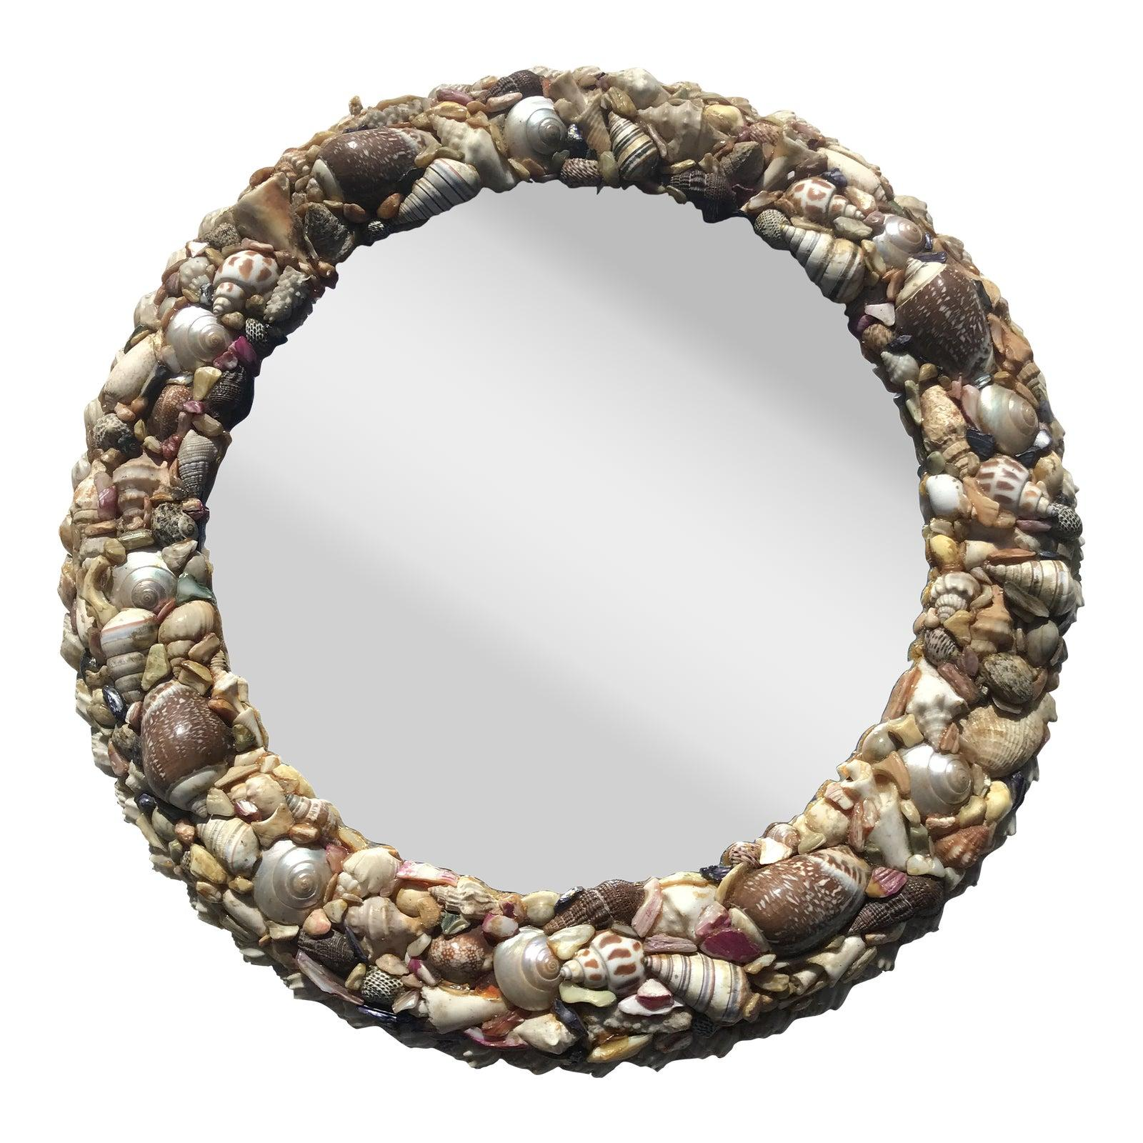

* CATEGORIES

Bedroom Mirrors

* MATERIALS

LED Mirrors

* SHAPE

Circle

* BRAND

Inax